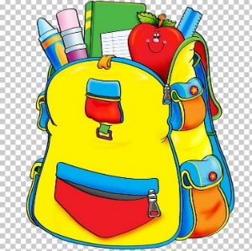
June 2021

New Maryland Elementary School
List of Supplies (2021 – 2022)
Grade 5 IF

Dear Parents and Students,

Welcome to Grade 5!

- A $45.00 fee will be collected from each student to cover the cost of school supplies for this year. This money will be used to purchase most of your child’s supplies for the entire year. ASD-W’s preferred form of payment is through Cashless. You are able to register – a simple task that takes less than 2 minutes by visiting https://www.schoolcashonline.com/ or visiting our website at http://web1.nbed.nb.ca/sites/ASD-W/NMES/Pages/default.aspx and navigating your way to the School Cash Online on the right hand side of the screen. Fees will be set to go live on Cashless the last week of August.

The only items your child needs to bring with them in September include:

- 1 - pair on Indoor sneakers (non-marking soles please)
- 1 - box of Kleenex
- 1 - pair of earbuds or headphones
- 1 - book bag & 1 lunch bag
- 1 - plastic pencil box

Thank you and we look forward to meeting you in September!

Sincerely,

Grade 5IF Teachers

